Improvement on ModBus Dashboard
- MAIN SIDEBAR
- Add MKS logo (at light logo) and change ModBas name to company name (MKS Instruments). At Collapse word remove it (1) and replace with company copyright (Elliance V1.0.0). For collapse button can add like below
2

<
1

- OVERVIEW PAGE
- Can we categorize it like below. Design can follow current design

Title
POWER
1. Total Active Power
2. Apparent Power
3. Peak Demand
4.Avg Power Factor
Voltage/Current
1. Avg Voltage
2. Avg Current
3. Avg Voltage THD
4.Avg Current THD
5. Avg Freq

Digital Output
1. Digital Output 1
2. Digital Output 2

Energy
1. Import Energy
2. Export Energy

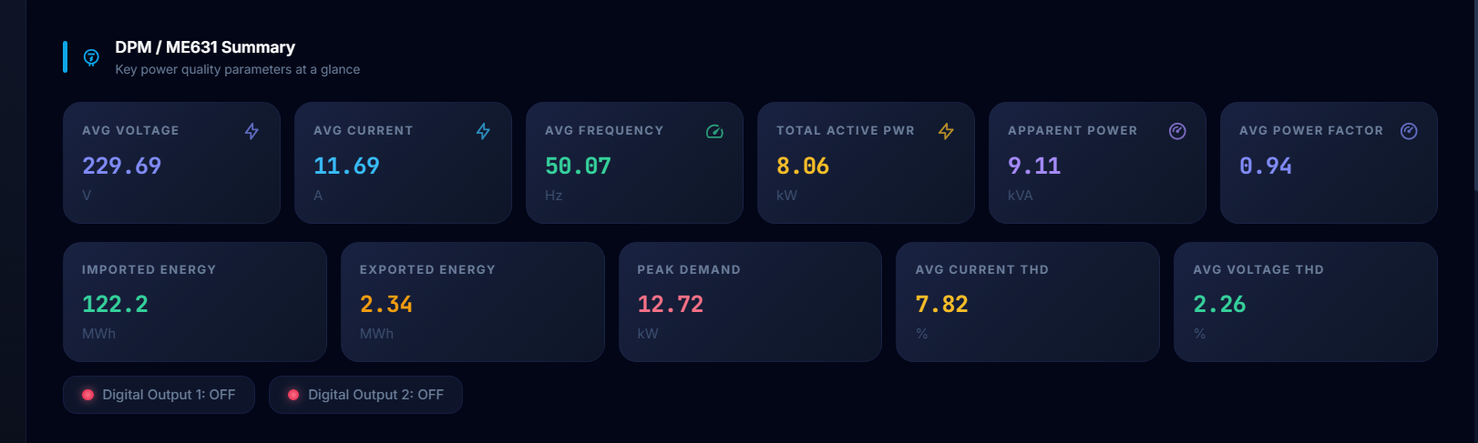

- Can align box of power, current & voltage with Active Alarm box

Title

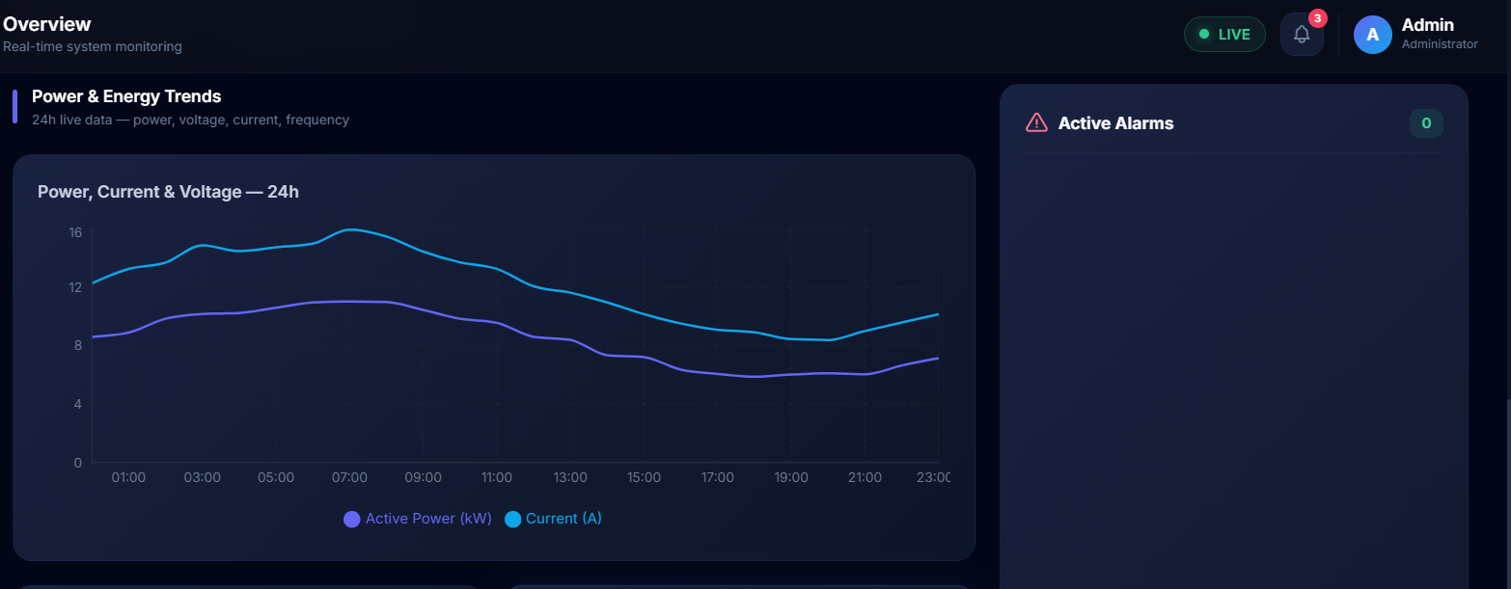

- GENSET PAGE
- Can increase it font size for L1-N, L2-N, L3-N, L1, L2 and L3
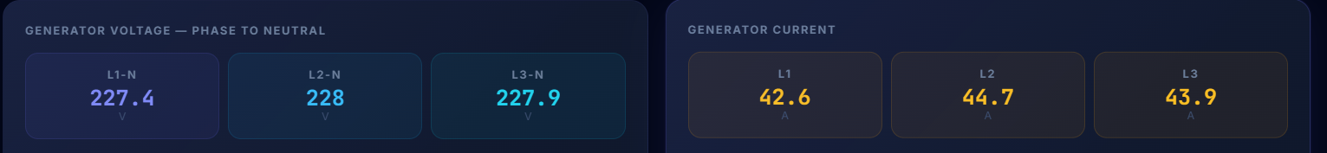

- For this dropdown button can make it colour
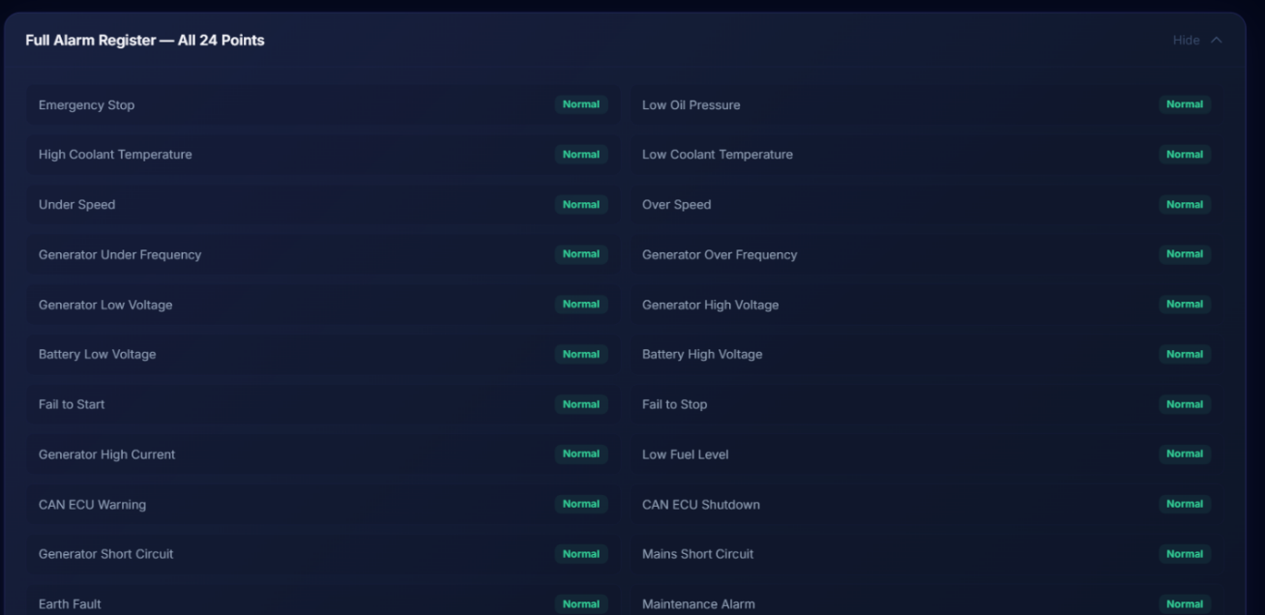

- Maybe can add the highlighted in one card/box

System Status
Mains Available Generator Available
Mains Breaker Generator Breaker

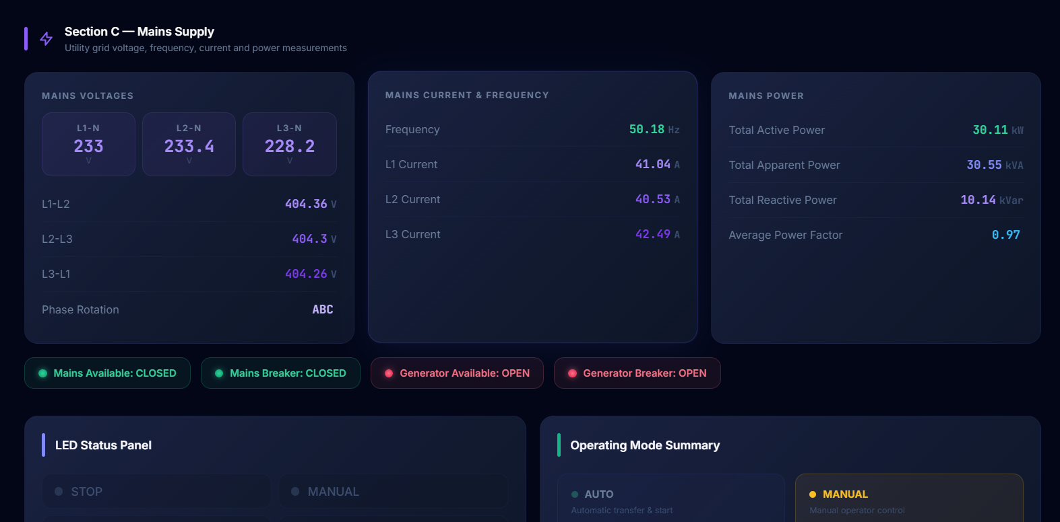
- DPM PAGE
- Can increase font for DPF1, DPF2, DPF3 and DPFAVG

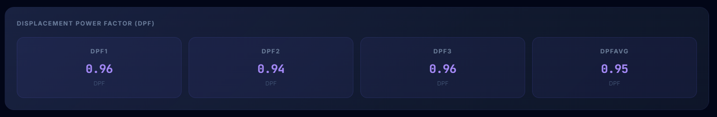

- Can increase font for I1, I2 and I3

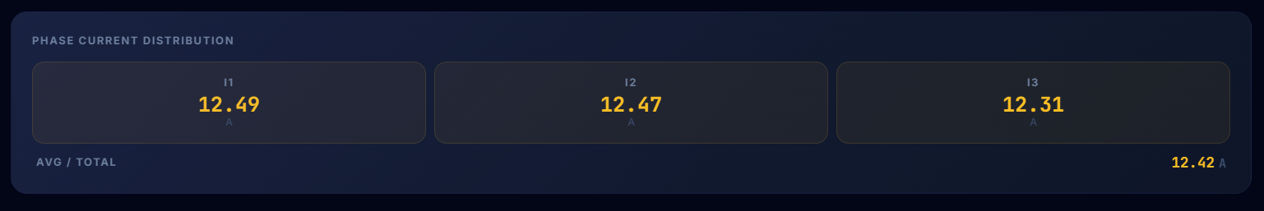

- Please add some gap between these 2 boxes





- Can make boxes for import different colour it look same with background colour

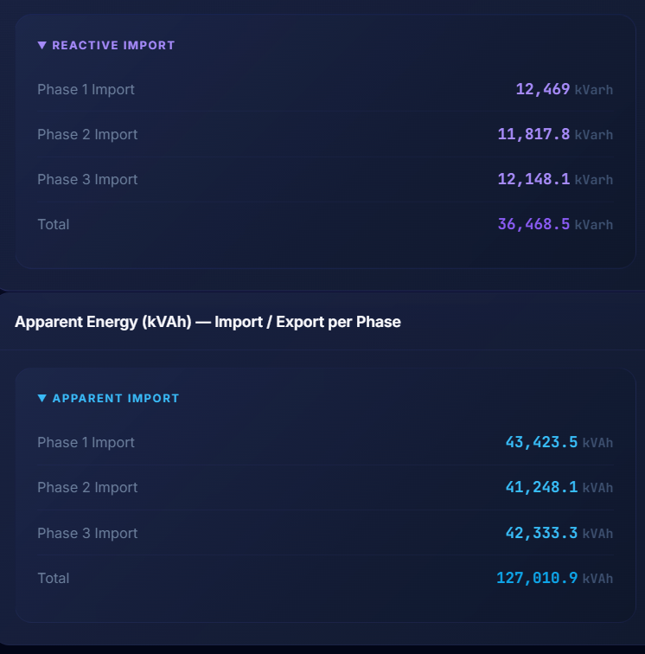

- Increase font size for I1, I2, I3 and IAVG and change colour for description in red boxes for I1, I2, I3 and IAVG.
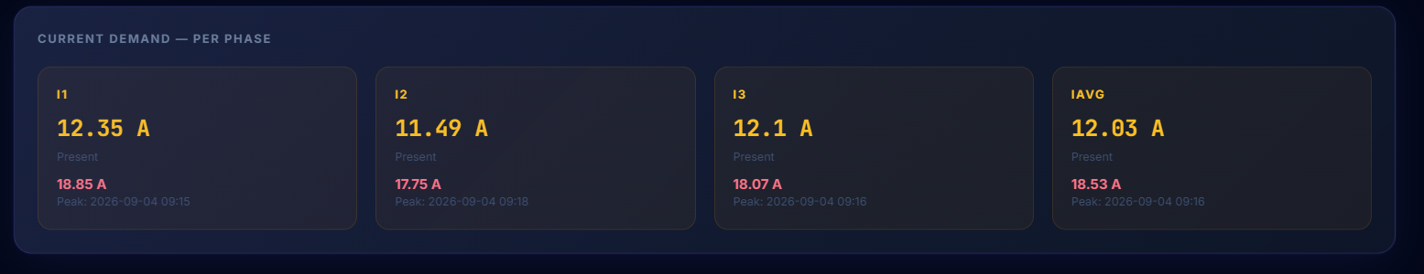

- Why only have graph for PTotal and STotal only? But in Manual has for FQTotal
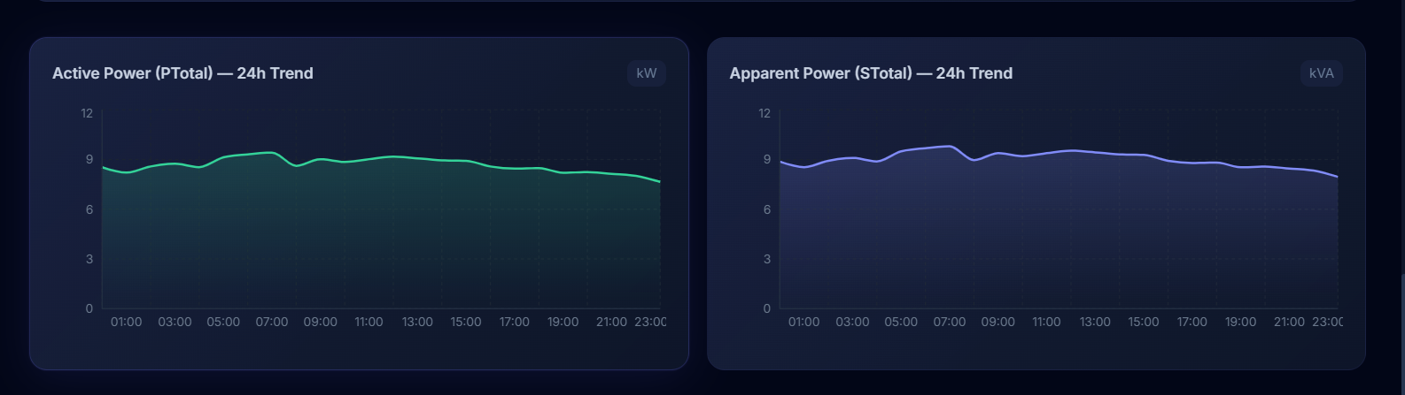

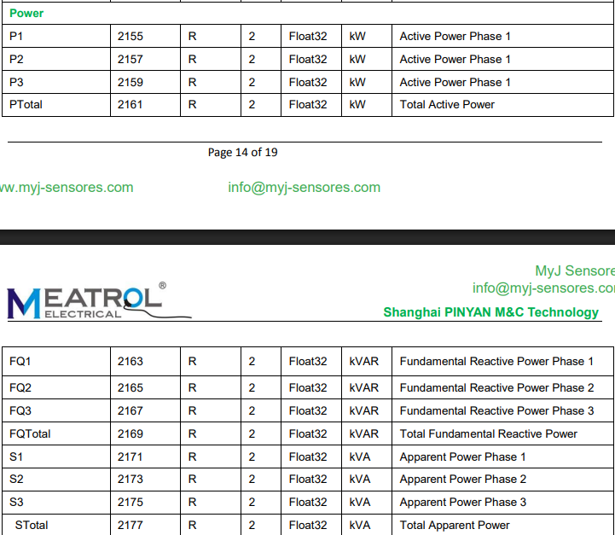

- SETTING PAGE
- Increase size of delete button

- Change colour of description because the font small and the almost similar with background



